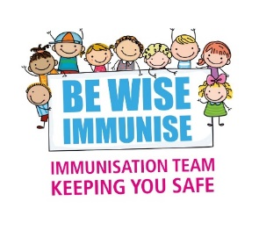

Immunisation & Vaccination Service
Community Health & Wellbeing
Wayside House
Wilsons Lane
Coventry
CV6 6NY

February 2024

Dear Parent/ Guardian
There have been an increasing number of confirmed measles cases in the West Midlands, including in Coventry & Warwickshire. The NHS, Public Health, and Education have been working together to reduce the spread of measles.
Children are routinely offered an MMR vaccine at the age of 1 years, and a pre-school booster at 3 ½ years. The School Aged Immunisation Service (SAIS) supports in delivering and catching-up children who may have missed one or both doses of the Measles Mumps and Rubella vaccination (MMR) when they were younger.
Children in school years 8 & 9 are part of the routine school MMR catch-up programme. Those who may have missed an MMR vaccine are individually contacted. This will continue as normal until the end of the academic year.
To help boost protection and reduce the spread of measles, SAIS is also offering to give the MMR vaccine to those in school years 7 to 13, who may have missed a dose.
Please contact the team who will be able to discuss the vaccination, gain consent, and advise when they will be in your child’s school.
Coventry School Aged Immunisation Team: Tel: 02476 961422. Email:Bewise.Immunise@covwarkpt.nhs.uk

The MMR vaccine is the most effective way to protect your child against measles mumps and rubella, millions are given each year. Most side effects are mild and do not last long. Visit https://www.nhs.uk/mmr for more information about the vaccine.

Kind Regards
School Aged Immunisation Service

